CHEERING SECTION; He Has Met the Mets and He Owns Them

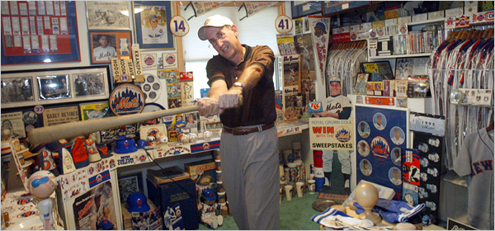
Susan Stava for The New York Times
Andy Fogel of Suffern, N.Y., and his Mets memorabilia. His wife, Rona, sets limits but admits, “It’s better
than a mistress.”
By VINCENT M. MALLOZZI
Published: September 24, 2006
Even Hollywood has made the pilgrimage to the mecca of Mets memorabilia, a shrine to Andy Fogel's favorite team.
''I was 12 when the Mets were born in 1962,'' said Fogel, 56, who grew up in Brooklyn as the son of Dodger fans. ''I grew up with the Mets, and I know an awful lot about their history.''
He owns a lot of it as well, an estimated 3,000 pieces, including Jerry Grote's catching equipment from the 1960's; jerseys worn by Casey Stengel, Gil Hodges and Tom Seaver; and team-autographed baseballs from every season in Mets history.
In a never-ending bid to add to his Amazin' collection, Fogel spends about 25 hours a week visiting auction sites on the Internet and auction houses, a pastime he began to pursue seriously in 1990 after he and his wife, Rona, visited the Metropolitan Museum of Art in Manhattan.
''I saw a whole room filled with an art collection donated by one man,'' he recalled. ''It was quite inspiring.''
So he began collecting everything Mets: autographed baseballs, pictures, postcards, pennants, yearbooks, programs, bobble-head dolls, even an original wood seat from Shea Stadium.
He also owns unused tickets from every home and away postseason game in Mets history; a life-size Tom Seaver cardboard cutout from 1968; a 1969 World Series ring; a mannequin dressed in the complete 1973 uniform of the former Mets coach Roy McMillan; and jerseys worn by 24 members of the 1986 championship team.
Most of those items are displayed in the bedroom that once belonged to Fogel's daughter, Lauren, before she married five years ago, but there is much more in the basement of his house in Suffern, N.Y. When his son, Joshua, married two years ago, Fogel wanted to combine both bedrooms to increase the size of his Metropolitan area.
''I told him that if he did that, he could take up residence in the garage,'' Rona Fogel said. ''Hey, look, it's a great collection, and it's better than a mistress, but I still have to push him back if he oversteps his boundaries.''
Fogel has sold only one item from his collection, a 1969 Ed Charles World Series jersey. Price: $20,000. Reason: Priceless.
''I used the money to pay for my daughter's wedding,'' he said.
Having retired last year from the Port Authority of New York and New Jersey as an assistant director in charge of E-ZPass, Fogel often takes relatives, friends and fellow collectors for a two-hour spin through what Ya Gotta Believe is the world's first Mets museum.
The collection includes such rare items as a cigarette lighter that plays ''Meet the Mets,'' with a picture of Mr. Met on one side and Shea on the other, and name plates that once hung over the lockers of players from the 1960's like Ed Kranepool and Marvelous Marv Throneberry.
Among Fogel's oddest items are a set of window curtains, adorned with Mr. Met and team logos, that had belonged to Joan Payson, the team's original owner, and a straw hat that she wore at Shea during the 1969 World Series.
Perhaps the most historically significant pieces are five pages of short evaluations of the 1964 Mets handwritten by Stengel, the team's first manager.
Stengel's evaluation of Ron Hunt, which Fogel has framed with others, reads: ''Demands that a ballplayer outplay him at second base. If so, he will try another position. Good, hard, tough game player that can execute almost every play. Could cover more ground.''
Memorabilia from Fogel's collection appeared in the 2000 movie ''Frequency,'' which starred Dennis Quaid and James Caviezel as a father and son who root for the Mets and communicate by radio across 30 years to track a murderer.
In August, ''Mets Weekly,'' a show on SNY, the Mets' network, filmed a segment at Fogel's house, and members of the team's public relations staff toured his treasured souvenirs. The team is considering using some of his collectibles for inclusion in yearbooks, programs or celebrations.
But Fogel has visions of an even longer shelf life.
''Maybe the Mets will open a museum inside their new stadium,'' he said. ''I could certainly loan them some of my stuff for display.''

