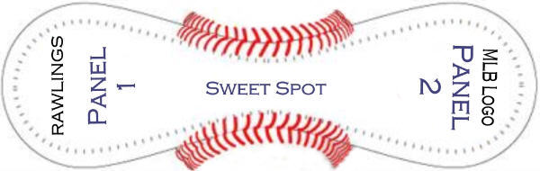

SWEET SPOT:

Joe Torre

PANEL 1:

Jose Vizcaino
Roger Clemens
Andy Pettitte
Tony Cloninger
Doc Gooden
David Cone (sideways)
Chuck Knoblauch
Denny Neagle
Jorge Posada

PANEL 2:

Orlando Hernandez
Bernie Williams
Ted Lilly
Tino Martinez
Don Zimmer
Scott Brosius
Willie Randolph
Paul O’Neill

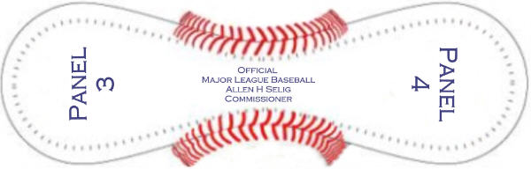

BALL LOGO PANEL:

Official
Major League Baseball
Alan H Selig
Commissioner

PANEL 3:

Randy Choate
Billy Conors
Glenallen Hill
Mike Stanton
Jose Canseco (sideways)
Luis Polonia
Chris Chambliss
Lee Mazilli
David Justice

PANEL 4:

Clay Bellinger
???
Ramiro Mendoza
Mariano Rivera
Derek Jeter
Jeff Nelson
Chris Turner
Luis Sojo

