CERTIFICATE of AUTHENTICITY

C Cubed Productions, Inc. certifies that the item purchased by the holder of this certificate is authentic.

This Black and White 8” x 10” Photo was signed in my presence by the Participants of the Colorado Rockies 2005 Winter Development Program.

It contains 23 Autographs including: Dan O’Dowd (Rox GM), Clint Hurdle (former Mgr), Jim Johnson (Coach), Jim Wright (Coach). Juan Morillo, Chris Narveson, Ryan Shealy, Ryan Speier, Dexter Fowler, Ubaldo Jimenez, Tony Miller, Chris Iannetta, Matt Macri, Ryan Spilborghs, Jeff Salazar, Ian Stewart, Jayson Nix, Jeff Baker, Jim Miller, Chris Nelson, Eric Young Jr. and Drew Goodman (Announcer).

Please be aware that C Cubed Productions, Inc. will be unable to authenticate any subsequent sales or transfers by the Buyer to a third party.

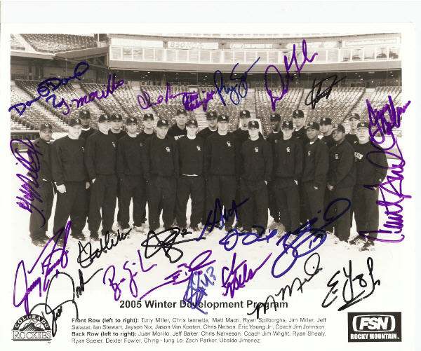

___________________________________

Christopher R Smith
Owner / President
C Cubed Productions, Inc.

